THÔNG TIN CÁ NHÂN
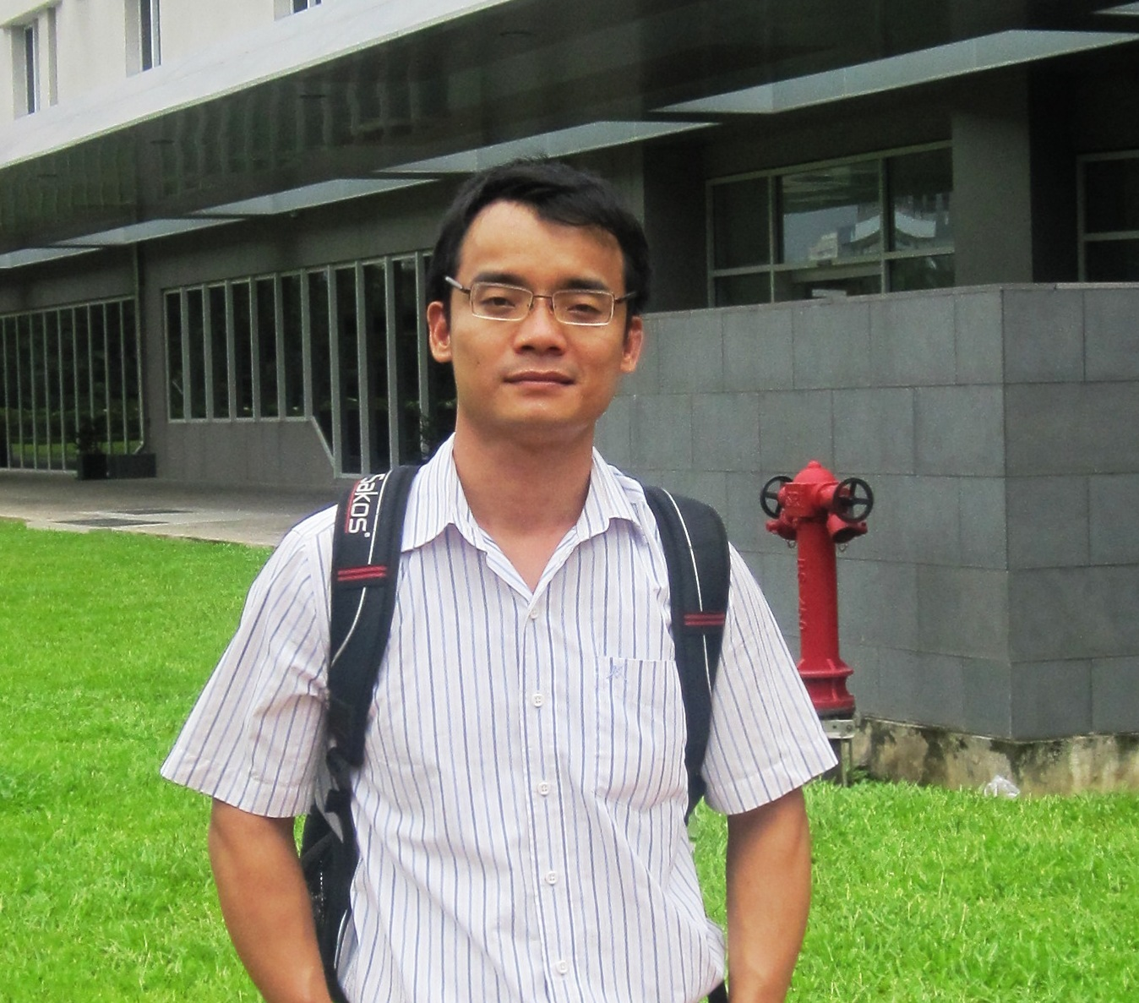
Họ tên: Lê Thành Cường
Đơn vị công tác: Giảng viên Viện Nuôi trồng Thủy sản
Trường Đại Học Nha Trang
Địa chỉ: 02, Nguyễn Đình Chiểu, Nha Trang, Khánh Hòa
Email: ltcuong2008@gmail.com ; ltcuong2008@yahoo.com.vn

QUÁ TRÌNH ĐÀO TẠO
- Nghiên cứu sinh (2015-2019): Viện Nghiên cứu Biển và Nam cực- Đại học Tasmania, Úc
- Cao học (2009-2011): Khoa Hải Dương học-Đại học Quốc gia Jeju, Hàn Quốc
- Đại học (2002-2006): Khoa Nuôi trồng Thủy sản-Đại học Cần Thơ
HOẠT ĐỘNG CHUYÊN MÔN
Giảng dạy: Miễn dịch học và ứng dụng trong nuôi trồng thủy sản
Kiểm dịch Động vật Thủy sản
Bệnh học thủy sản
Nghiên cứu (các dự án đã tham gia):
  - Khảo sát một số bệnh nguy hiểm thường gặp ở tôm chân trắng (Litopenaeus vannamei) nuôi thương phẩm tại Ninh Thuận và đề xuất biện pháp phòng ngừa, điều trị (2013-2015).
  - Nghiên cứu vòng đời của sán lá đơn chủ thuộc họ Capsalidae ký sinh trên cá biển nuôi tại Khánh Hòa (2012-2015)
  - Đánh giá tác động môi trường của tràn dầu và sự phục hồi của môi trường ở Hàn Quốc (2009-2011).
  - Biến động lâu dài của cấu trúc và chức năng hệ sinh thái nước mặn của Hàn Quốc (2009-2011).
  - Tham gia tổ công tác nghiên cứu giải quyết Bệnh sữa trên tôm hùm nuôi tại các tỉnh miền Trung Việt Nam năm 2007.
  - Nghiên cứu kí sinh trùng và mô học trên cá tra bị bệnh vàng da nuôi tại một số tỉnh Đồng bằng Sông Cửu Long năm 2005-2006.

CÔNG TRÌNH KHOA HỌC
- Hyun-Ki Hong, Hyun-Sil Kang, Thanh Cuong Le, Kwang-Sik Choi. 2013. Comparative study on the hemocytes of subtropical oysters Saccostrea kegaki (Torigoe & Inaba, 1981), Ostrea circumpicta (Pilsbry, 1904), and Hyotissa hyotis (Linnaeus, 1758) in Jeju Island, Korea: morphology and functional aspects. Fish & shellfish immunology, 35, 2020-2025.
- Limpanont, Y., Kang, H.-S., Hong, H.-K., Jeung, H.-D., Kim, B.-K., Le, T.C., Kim, Y.-O., Choi, K.-S. 2013. Molecular and histological identification of Marteilioides infection in Suminoe Oyster Crassostrea ariakensis, Manila Clam Ruditapes philippinarum and Pacific Oyster Crassostrea gigas on the south coast of Korea. Journal of Invertebrate Pathology, 114, 277-284.
- Thanh Cuong Le, Kwang-sik Choi, 2012. Co-infection and histopathological effects of digenean trematode larva in Manila clam (Ruditapes philippinarum) in Western Korean coast. International Fisheries Symposium- IFS 2012. Can Tho 6-8th December, 2012. Sharing Knowledge for Sustainable Development of Aquaculture and Fisheries in Southeast Asia.
- Cuong Thanh Le, Hyun-Sil Kang, Kwang-Jae Park, Kwang-Sik Choi, 2011. First record on the occurrence of Urosporidium hyperparasite in trematode infected Manila clam, Ruditapes philippinarum from the west coast of Korea. 1st Asian Congress of Protistology (ACOP) and the 8th Asian Conference of Ciliate Biology. October, 3-6, 2011. Jeju, Korea. P53.
- Cuong Thanh Le, Hyun-Sung Yang, Kwang-Jae Park, Hyon-Sob Han and Kwang-Sik Choi, 2011. The prevalence and intensity of Perkinsus olseni infection in Manila clam Ruditapes philippinarum surveyed along the west coast of Korea. the Eighth IOC/WESTPAC International Scientific Symposium titled "Ocean Climate and Marine Ecosystems in the Western Pacific". The Intergovernmental Oceanographic Commission (IOC) of UNESCO. March 28-31, 2011. Busan. Korea. P279.
- Cuong Thanh Le, Kwang-Jae Park and Kwang-Sik Choi, 2011. First report on the occurrence of Haplosporidian hyperparasite in Manila clam, Ruditapes philippinarum on the west coast of Korea. Korean Society of Malacology. Busan. Korea. P42.
- Cuong T.Le, Hyun-Sung Yang, Kwang-Jae Park, Hyon-Sob Han and Kwang-Sik Choi, 2010. Spatial variation of Perkinsus olseni infection in Spring season in Manila clam along the west coast of Korea. Annual conference on the Green Growth and Fisheries Science. The Fishery Sciences Association of Korea (FSAK).BEXCO, Busan, Korea. P187.
- Cuong T.Le, Ronald G. Noseworthy, and Kwang-Sik Choi. 2010. Biodiversity of commercially valuable marine bivalve fauna of Jeju island, Republic of Korea. Proceedings of International Conference on Marine biodiversity of East Asian seas: Status, challenges and sustainable development.December 6-7, 2010, Nha Trang, Vietnam. P 40-45.
- Tu Thanh Dung, Pham Thanh Huong, Le Thanh Cuong and Dang Thuy Mai Thy, 2008. Study pathological characteristic of yellow fillet syndrome in Striped catfish (Pangasianodon hypophthalmus) in the Mekong Delta. International symposium on Catfish Aquaculture in Asia: Present Status And Challenges For Sustainable Development. 5-7 December, 2008. Can Tho, Vietnam. P104.

CURRICULUM VITAE
Full name: Cuong Thanh, Le
Office: Lecturer, Faculty of Aquaculture
Nha Trang University
Address: 02 Nguyen Dinh Chieu St
Email: ltcuong2008@gmail.com
ltcuong2008@yahoo.com.vn

EDUCATION

- PhD (2015-2019): Institute for Marine and Antarctic Studies- University of Tasmania – Australia
- Master (2009-2011): Master of Marine life Science - School of Marine Biomedical Science, Jeju National University) – South of Korea
- Bachelor (2002-2006): Bachelor of Aquatic Pathobiology - Can Tho University - Vietnam
EXPERIENCE
Teaching:
Immunology and Application in Aquaculture
Aquatic Animal Quarantine
Aquatic Animal Pathology
Researching (projects participated):
Studying serious, commonly found diseases in Pacific white leg shrimp (Litopenaeus vannamei) cultured commercially in Ninh Thuan province and suggesting the prevention, treatment methods (2013-2015).
Researching the life cycle of Capsalidae monogeneans parasitizing on marine fishes in Khanh Hoa province (2013-2015).
Oil Spill Environmental Impact Assessment and Environmental Restoration in South of Korea (2009-2011).
Long-term change of structure and function in marine ecosystems of Korea (2009-2011).
Outbreak of milky haemolymph disease of net-pen-reared spiny lobsters in Vietnam in 2007.
Epidemiology, histopathology and parasitic disease of cultured freshwater catfishs, Pangasius hypophthalmus caught yellow fillet syndrome in the Mekong Delta, Vietnam, 2005 – 2006.
PUBLICATION
- Hyun-Ki Hong, Hyun-Sil Kang, Thanh Cuong Le, Kwang-Sik Choi. 2013. Comparative study on the hemocytes of subtropical oysters Saccostrea kegaki (Torigoe & Inaba, 1981), Ostrea circumpicta (Pilsbry, 1904), and Hyotissa hyotis (Linnaeus, 1758) in Jeju Island, Korea: morphology and functional aspects. Fish & shellfish immunology, 35, 2020-2025.
- Limpanont, Y., Kang, H.-S., Hong, H.-K., Jeung, H.-D., Kim, B.-K., Le, T.C., Kim, Y.-O., Choi, K.-S. 2013. Molecular and histological identification of Marteilioides infection in Suminoe Oyster Crassostrea ariakensis, Manila Clam Ruditapes philippinarum and Pacific Oyster Crassostrea gigas on the south coast of Korea. Journal of Invertebrate Pathology, 114, 277-284.
- Thanh Cuong Le, Kwang-sik Choi, 2012. Co-infection and histopathological effects of digenean trematode larva in Manila clam (Ruditapes philippinarum) in Western Korean coast. International Fisheries Symposium- IFS 2012. Can Tho 6-8th December, 2012. Sharing Knowledge for Sustainable Development of Aquaculture and Fisheries in Southeast Asia.
- Cuong Thanh Le, Hyun-Sil Kang, Kwang-Jae Park, Kwang-Sik Choi, 2011. First record on the occurrence of Urosporidium hyperparasite in trematode infected Manila clam, Ruditapes philippinarum from the west coast of Korea. 1st Asian Congress of Protistology (ACOP) and the 8th Asian Conference of Ciliate Biology. October, 3-6, 2011. Jeju, Korea. P53.
- Cuong Thanh Le, Hyun-Sung Yang, Kwang-Jae Park, Hyon-Sob Han and Kwang-Sik Choi, 2011. The prevalence and intensity of Perkinsus olseni infection in Manila clam Ruditapes philippinarum surveyed along the west coast of Korea. the Eighth IOC/WESTPAC International Scientific Symposium titled "Ocean Climate and Marine Ecosystems in the Western Pacific". The Intergovernmental Oceanographic Commission (IOC) of UNESCO. March 28-31, 2011. Busan. Korea. P279.
- Cuong Thanh Le, Kwang-Jae Park and Kwang-Sik Choi, 2011. First report on the occurrence of Haplosporidian hyperparasite in Manila clam, Ruditapes philippinarum on the west coast of Korea. Korean Society of Malacology. Busan. Korea. P42.
- Cuong T.Le, Hyun-Sung Yang, Kwang-Jae Park, Hyon-Sob Han and Kwang-Sik Choi, 2010. Spatial variation of Perkinsus olseni infection in Spring season in Manila clam along the west coast of Korea. Annual conference on the Green Growth and Fisheries Science. The Fishery Sciences Association of Korea (FSAK).BEXCO, Busan, Korea. P187.
- Cuong T.Le, Ronald G. Noseworthy, and Kwang-Sik Choi. 2010. Biodiversity of commercially valuable marine bivalve fauna of Jeju island, Republic of Korea. Proceedings of International Conference on Marine biodiversity of East Asian seas: Status, challenges and sustainable development.December 6-7, 2010, Nha Trang, Vietnam. P 40-45.
- Tu Thanh Dung, Pham Thanh Huong, Le Thanh Cuong and Dang Thuy Mai Thy, 2008. Study pathological characteristic of yellow fillet syndrome in Striped catfish (Pangasianodon hypophthalmus) in the Mekong Delta. International symposium on Catfish Aquaculture in Asia: Present Status And Challenges For Sustainable Development. 5-7 December, 2008. Can Tho, Vietnam. P104.

